
Annual Report
2025 – 2026
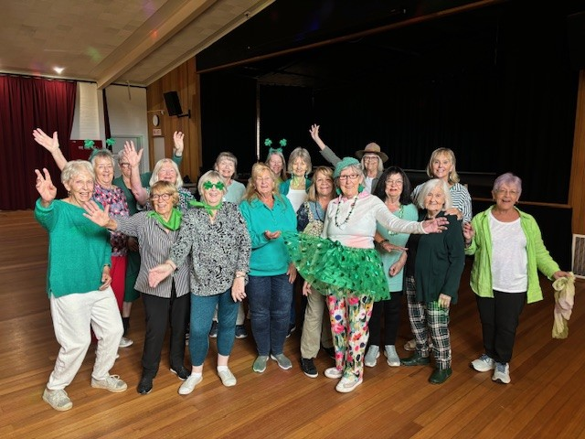
The Dancing in the Dark group celebrating St Patricks Day – March 2026

A connected, inclusive and vibrant community
PNH remains committed to:
- Expanding opportunities for learning and wellbeing.
- Strengthening community partnerships.
- Supporting our volunteers.
- Providing inclusive and affordable activities.
- Creating welcoming spaces where everyone belongs.

Presented at the Annual General Meeting September 17th, 2026
Contents

- President's Report
- Committee of Management Report
- Program Manager's Report
- Our Year - Statistics
- Our Year - Events
- Our Year - Activities and Attendance
- Our Year – Supporters & Sponsors
- Our Year - Personnel
- Financial Overview
- Financial Report (attached)

Strategic Goals

- Our governance and administration practices are grounded in accountability, transparency and achievement

- Our program is growing to meet the diverse needs of our membership and community

- Our membership is growing to better reflect community demographics

- Our community is growing in awareness and engagement with PNH

- Our members are supporting and engaging new ideas through friendship and connections

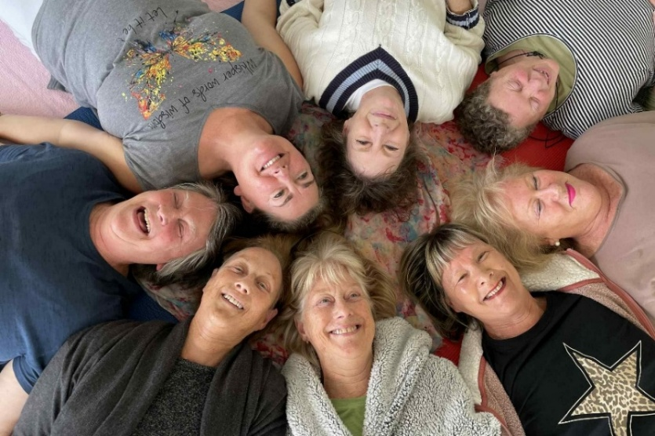
Monday Yoga class relaxing at the end of their session 2025

President's Report
It is a privilege to reflect on another successful year at Portarlington Neighbourhood House and the important role it continues to play in our community.
Belonging to a community has always been important in our lives, and PNH endeavours to provide a place where those connections can happen. But it is you — our members and local residents — who create the connections between yourselves. I often see examples of thoughtfulness, inclusion and people ‘keeping an eye’ on their neighbours and friends. These simple acts of kindness and connection are increasingly important in our ever-changing and sometimes challenging world.
These moments reflect the true purpose of a neighbourhood house. Over the past year, we have strengthened our sense of community through our diverse programs, growing partnerships and the unique setting of Parks Hall.
Like other neighbourhood houses across Victoria, we continue to face financial pressures. However, the Keep Our Doors Open campaign highlighted the vital role neighbourhood houses play in their communities. The heartfelt support we received reminded us just how much PNH means to the people of Portarlington.
Our success is only possible because of the commitment of our volunteers, facilitators, staff, Committee of Management, members, supporters and community partners. Thank you for your continued support and contribution.
Together, we will ensure Portarlington Neighbourhood House remains a vibrant, welcoming and valued part of our community

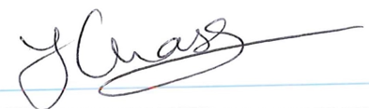 Jackie Chase, President

Committee of Management Report
Strategic goal: Our governance and administration practices are grounded in
accountability, transparency and achievement

Over the past twelve months, the Committee of Management has continued to focus on strengthening the governance, planning and sustainability of PNH. Key areas of work include:
· Redeveloping and endorsing the 2026–2031 Strategic Plan, available on our website. This plan provides a clear framework for decision-making, planning and continuous improvement over the next five years.
· Reviewing the proposed Parks Hall redevelopment plan and making the difficult decision to withdraw from the project after Council advised there was no foreseeable funding to proceed and that PNH could be exposed to financial risk. We advised key stakeholders of this decision and returned the grant funds.
· Implementing new DFFH guidelines and reporting requirements to ensure PNH continues to meet its funding and compliance obligations.
. Completing an independent financial audit by WPG auditor Warren Pollock for year ending 30th June 2025
· Reviewing and updating PNH operational policies to improve transparency and accessibility.
· Refreshing and updating the PNH website to better support communication with members, volunteers and the wider community.

Program Manager's Report
Strategic goal: Our Program is growing to meet the diverse needs of our membership and community

Our Members and Activities
One of the highlights of the year has been the consistently strong attendance across our programs. It has been wonderful to see our activities so well supported by members, and this has encouraged us to continue expanding what we offer.
Throughout the year we introduced new activities and increased the number of workshops available, providing more opportunities for members to learn new skills, connect with others, and enjoy everything our centre has to offer. We look forward to building on this momentum in the year ahead.
Our Staff and Committee
This brings me to our staffing team.
Over the past year we have continued to focus on developing a proactive and professional workplace culture. Our office staff have worked hard to become more informative, approachable, and engaging with our members and clients. They continue to perform their roles with care, professionalism, and pride, ensuring everyone who contacts or visits the centre receives a positive experience.
Our facilitators also play a vital role in the success of our programs. We encourage them to take an active interest in the wellbeing and success of each activity, continually seeking ways to improve, refresh, and enhance the experiences they deliver. Their willingness to adapt and innovate helps keep our programs engaging and relevant.
I would also like to acknowledge the Committee of Management. Throughout the year, the Committee has remained committed to developing and maintaining sound organisational policies, ensuring good governance, and monitoring the wellbeing of both the organisation and its staff. Their guidance and dedication provide the strong foundation needed for our continued success.
Year Highlights
There have been many memorable moments throughout the year, but perhaps the greatest highlight has simply been seeing so many happy faces coming through our doors each day. Watching members connect, learn, laugh, and enjoy our centre reminds us why we do what we do.
Events stood out as they demonstrated our organisation's ability to plan, deliver, and manage events that genuinely reflect the interests and wishes of our members. Their success gives us confidence to continue developing exciting opportunities in the future.
Looking Ahead
As we move into the new year, we remain committed to strengthening our organisation, expanding our activities, supporting our members, and continuing to foster a welcoming, inclusive, and vibrant community. Some of the new programs include a community choir, cooking classes for beginners,
and a men’s mental health initiative that encourages connection, conversation and wellbeing run
in conjunction with The Men’s Table.

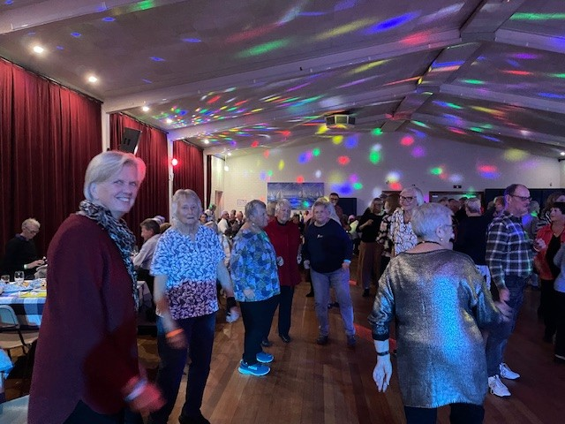  Newport Junction Concert – August 2025 | 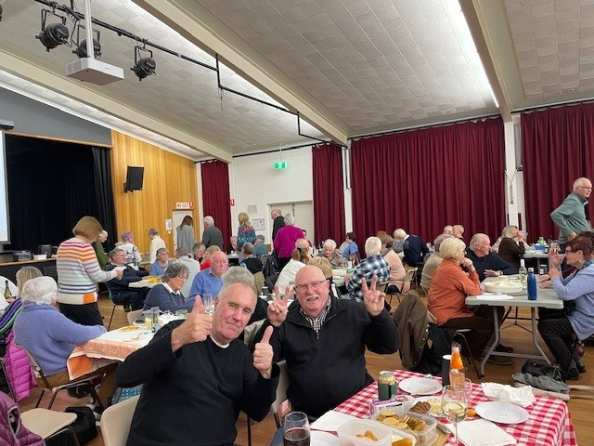  PNH Trivia Night 2025

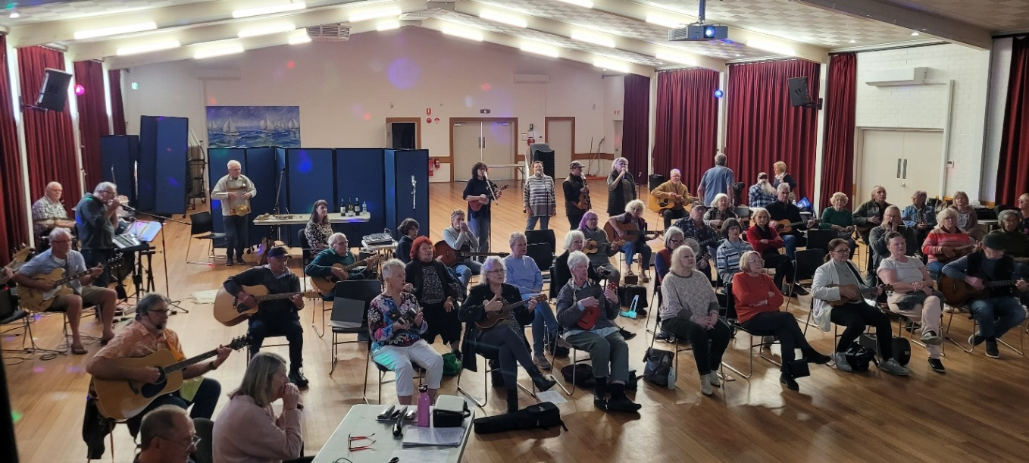
Port Jammers playing during open week - October 2025

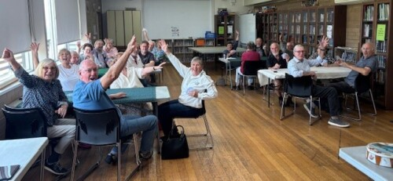
Cards 500 enjoying a game! December 2025

Our Year- Statistics

Strategic goal: Our membership is growing to better reflect community demographics
Throughout 2025–26, PNH continued to provide opportunities for people to connect, learn, stay active and contribute to our community. During the year we delivered a diverse range of activities, special events, information sessions and community partnerships that welcomed people of all ages and interests.
14,017  participant visits across the year | 1,099  activity sessions delivered
≈ 40  regular activities each week | 21+  community events held
601  members & associates at 30 June | 150  new members joined during the year
4,125  recorded volunteer hours | 1,097  Facebook followers — up 30%
Figures compiled from the PNH monthly data consolidation, 1 July 2025 – 30 June 2026.

Participation over time
 | 2022–23 | 2023–24 | 2024–25 | 2025–26
Total annual participations | 12,600 | 13,131 | 13,500 | 14,017
Activity sessions delivered | – | 1367 | 1265 | 1,099
Activity hours delivered | – | 2450 | 2204 | 1,977

Membership data
 | 2022 | 2023 | 2024 | 2025 | 2026
Members at 31 December (previous year) | N/A | 760 | 760 | 762 | ≈ 694
Members at 30 June | 563 | 682 | 570 | 568 | 601
New members during the year | – | – | – | – | 150
Membership includes Associate members. 2022–2025 figures are from the previous annual report; 2026 figures are from the monthly data consolidation

 | 2023–24 | 2024–25 | 2025–26
Facebook followers (at 30 June) | ≈ 670 | ≈ 700 | 1,097
Facebook page views (year) | – | – | ≈ 146,000
Newsletter open rate | – | – | 60–66%

Our Year - Events
Strategic goal: Our community is growing in awareness and engagement with PNH

July to Sept 2025 | - Trivia Night  - Mid-Winter Words  - Blue Moon Winter Dance  - Ten Pin Bowling  - African Adventures Photography afternoon  - Scam Awareness & Staying Safe on Facebook information session  - Sculpture Workshop
Oct to Dec 2025 | - Free Activities Week during Seniors Week (October)  - Movie & Lunch in Geelong  - Hearing Checks  - Archibald Exhibition  - Sea Glass Sun Catcher workshop  - Garden Club Garden Trail — visitors from across the region  - Bellarine Big Band Supper Dance  - De-Stash Market —  - Port Community Association & Musoden Band Night  - End of Year Celebration for members
Jan – March 2026 | - Welcome Back sausage sizzle  - Welcome to 2026 Retro Rebel Band Night  - Maritime Museum trip  - CPR training  - Bellarine Community Support Register information session  - Power Saving Bonus Scheme support
April-June 2026 | - Newport Junction Band Night  - BlazeAid Fundraising Concert  - De-Stash Market  - South Melbourne Market bus trip  - National Volunteers Week  - Beatles Bash event  - Trivia Night  - Family Bush Dance
All year  ongoing | - Social Afternoons

Our Year -Activities and Attendance
Strategic goal: Our members are supporting and engaging new ideas through friendship and connections

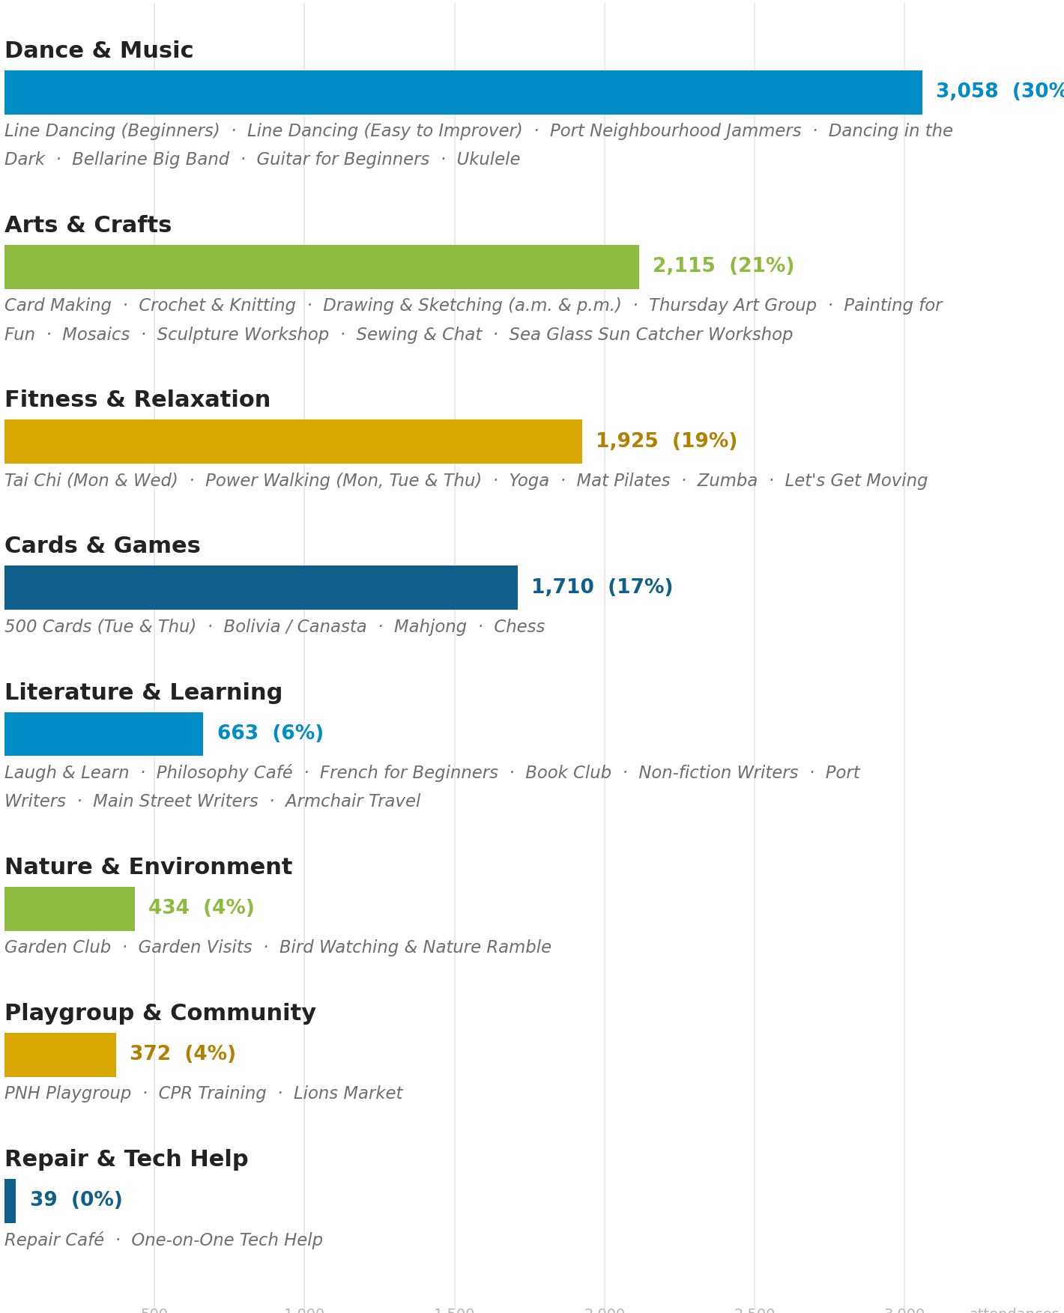
10,316 activity visits recorded across the year, compiled from the monthly attendance sheets. Activities are listed under the program area used in the monthly data consolidation; percentages show each area's share of total activity attendance.

Our Year -Personnel
People are at the heart of Portarlington Neighbourhood House. Every activity, event and service relies on members, volunteers, facilitators and staff working together to create a welcoming, inclusive and supportive environment.

 | 2025–26 | Notes
Recorded volunteer hours | 4,125 | Total hours recorded during the year
Activity facilitation | 1,744 | Hours spent facilitating activities
Office and reception | 972 | Hours staffing the office and reception
Committee | 801 | Hours serving on the Committee
Events | 608 | Hours planning and running events
Average volunteer positions filled each month | 132 | 88% of all activity facilitation hours were volunteer-led

Volunteer contribution over time
 | 2022–23 | 2023–24 | 2024–25 | 2025–26
Volunteer hours | 4,100 | 4,291 | 4,755 | 4,125*
Estimated value to the community | >$245,000 | >$250,000 | >$250,000 | >$250,000
*2025–26 hours are those recorded in the monthly data consolidation; ad-hoc volunteering and some committee months were not recorded, so the true figure is higher. Earlier figures are from the previous annual report.

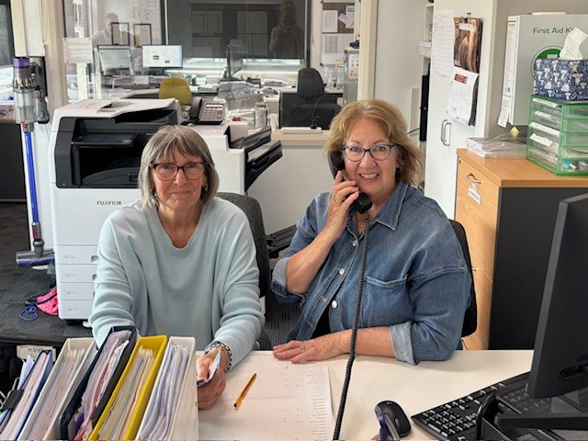
Office volunteers Helen and Judith – August 2026

Our Year - Supporters and Sponsors
Portarlington Neighbourhood House is sustained by the generosity of our funding bodies, partners, sponsors and donors. We gratefully acknowledge everyone who supported us in 2025–26.

Funding partners
- Victorian Government — Department of Families, Fairness and Housing (DFFH)
- City of Greater Geelong — including our subsidised lease agreement and annual grant.

Sponsors, donors and fundraising supporters
- Heenans Building Services – cash donation
- Hallettstone Memorials – cash donation
- Lions Club of Portarlington – cash donation
- Melbourne Symphony Orchestra – raffle prizes
- Portarlington Golf Club — raffle prizes
- Scotchmans Hill winery – raffle prizes
- Portarlington BakeHouse - raffle prizes
- Port Fish & Chips - raffle prizes
- Cellarbrations - raffle prizes
- Pop’s Bar - raffle prize
- Circulus Winery - raffle prize
- Mortimers Petrol - raffle prizes

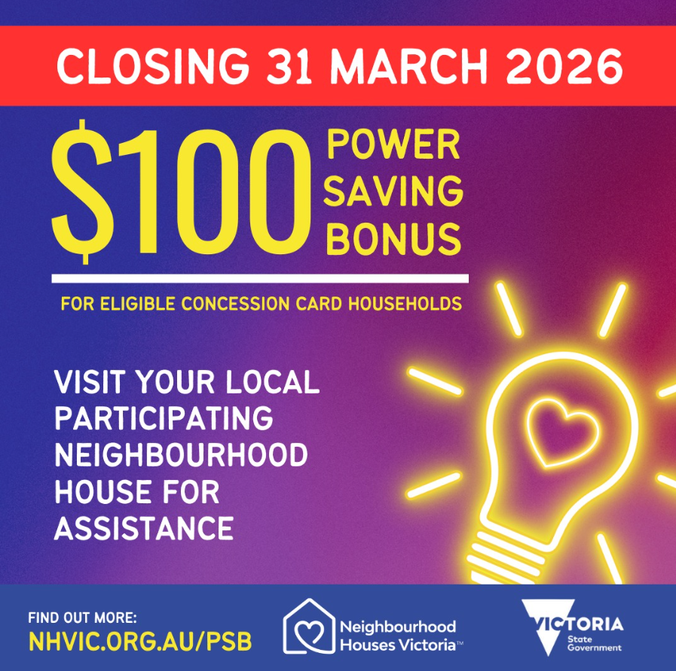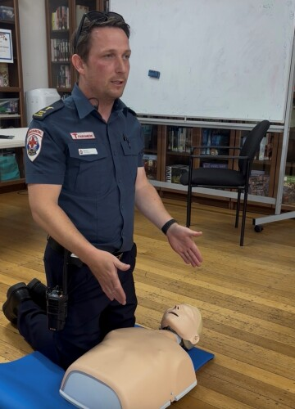
Power Saving Bonus scheme fund raiser Ambulance Australia CPR training, April 2026
Special thanks
Community events are made possible through the dedication of our volunteer event managers and coordinators. Special thanks to:
- Rob Sztogryn, Program Manager, for a growing and diverse community events program.
- Kate Hayes for our communications, newsletter, marketing and grant successes.
- Marg Jucker, coordinator of the Social Events Team.
- Jenny Macaulay and Julie Walker for another outstanding Trivia Night event.
- Deb Trotman - coordinator of the Blue Moon Winter Dance
- Jill Rees, coordinator of the two Destash Markets
- Murray Rees - coordinator of the Big Band Community events
- Margaret Belfrage - coordinator of the Beatles Bash and Community Bush Dance

And to all our personnel, some of whom volunteer in multiple areas

Committee of Management

Geoff McDonald
Grace Hough
Jackie Chase (and events)
Jacquie Wissenden
Marg Jucker (events and Card Making)
Margaret Belfrage (and Jammers)
Mark Chaffers
Rob Kolomeitz (and Events)
Sue Jager

Melita Proesbtl – Consultant Bookkeeper

Office Volunteers

Annie Bugeja

Bev Gimson
Diane Chaffers
Diane Ryan
Fran Scott
Julie Walker (and Laugh & Learn)
Katie Hall
Pauline Sandow
Phyllis Perry (and Dancing in Dark)

Hetty Anbeek – librarian

Events and Social Activities

Di Kolomeitz

Jan Clarke
Jill Rees – Destash Markets

Juliet Gavens
Rita Burleigh

Activity Facilitators

Annette Lewis – Garden Club
Des Lawrence -Tai Chi
Doreen Freeman -Drawing
Elise Clements- Art on Thursday
Emilia Kurek - Tai Chi

Gemma Tobschall - Bolivia
Hayden Whisken - Philosophy Café

Holly Cooper - Pilates
Jackie Milne - Laugh & Learn

Jenny MaCauley – Drawing & Writing

John Robotham -500 cards
Loris Phair -Book Club
Mary Micallef -Mahjong

Murray Rees -Bellarine Big Band

Pearl Wilson – Main St Writers
Peter Drew – Repair Shop

Peta O’Connell – Line Dancing

Rachel Sumich Antonik – Yoga

Robyn Hope - Mosaics
Sally Garden – Lets Get Moving
Stan Ruisniak - Chess
Suzie Ridgeway – Knitting & Crochet
Wayne Long – Bird Ramble

Total: 60+ volunteers

Thank You
We sincerely thank our volunteers, members, facilitators, sponsors, donors and community partners. Your time, generosity and commitment make Portarlington Neighbourhood House the vibrant and welcoming place it is today. Together we continue to build a stronger, more connected community.

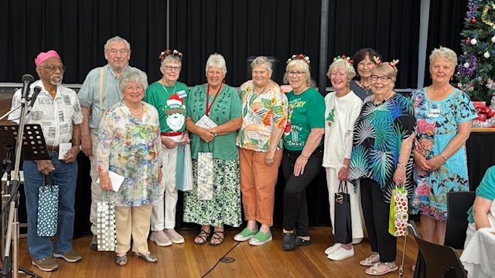
Celebrating those who have volunteered for 10+ years at PNH – December 2025

Portarlington Neighbourhood House · Annual Report 2025–26

Statistics compiled from the PNH monthly data consolidation, 1 July 2025 – 30 June 2026

Financial Overview
Finance Statement

In the opinion of the 2025-26 committee, the financial report attached:
- presents a true and fair view of the financial position of the Portarlington Neighbourhood House Inc. as of June 30th, 2026, and its performance for the year ended on that date
- on the date of this statement, there are reasonable grounds to believe that Portarlington Neighbourhood House Inc. will be able to pay its debts as they fall due.

This statement is made in accordance with a resolution of committee and is signed for and on behalf of the committee by:

President
Jackie Chase

Treasurer 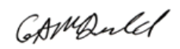
Geoff McDonald

Date of Committee resolution: 11th August 2026

