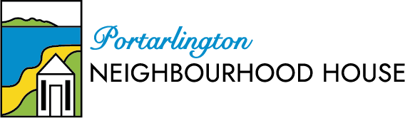

change innovation teamwork sharing the load

2023-24 actions & expected outcomes towards 2022-26 strategic goals

Purpose of the 2023-24 strategic action plan
Put simply, this 2023-24 action plan is part of the 5-year plan to achieve the strategic goals in Strategic Plan 2022-26.
2023-24 is the second year of this 5-year Strategic Plan.

Member Consultation Process
This action plan is open for member consultation until Wednesday 5th July.
Members are invited to contribute their ideas to the ‘way forward’ for Portarlington Neighbourhood House.
Written submission from members can be emailed to enquiry@portnh.org.au
Written submissions will receive a return email to acknowledge receipt of the submission. Committee will not reply to each individual submission. All submissions will be considered and the final version of the 2023-24 Strategic Action Plan will be made available to all members.

Strategic Plan 2022 - 2026
A 20 year goal: | Vision | Active and vibrant participation in the community
‘What we do’: | Mission | To provide opportunity for learning, and social and community connection
Strategic Goals
1 Our membership is growing to better reflect community demographics
2 Our program is growing to meet the diverse needs of our members and the community
3. Our members are supporting and engaging in new ideas through friendships and connections
4 Our community is growing in awareness and engagement with PNH
5 Our governance and administration practices are grounded in accountability, transparency and achievement

Data used to develop this annual plan
- Past financial performance data (up to May 2023)
- Operational performance KPIs as listed in the Performance Evaluation Framework
- Member Survey data
- Strategic Action Plan 2022-23 – actions & achievement

Overview of performance against the strategic goals 2022-23
Note that a more detailed performance report will be prepared for the AGM. This annual strategic action plan was based on data available in May 2023.

1 Our membership is growing to better reflect community demographics
- PNH high membership numbers is a strength (possibly the largest adult member club in Portarlington)
- 2022-23 has seen minimal progress towards attracting membership in demographics other than retirees. PNH does not have any attractions for them.

2 Our program is growing to meet the diverse needs of our members and the community
- The current program of activities & events is meeting member needs (survey data). 2023-24 brought many new activities. The introduction of the Event Committee to focus on events has been a significant success. Keeping the program ‘fresh’ and ‘diverse’ for all members is a challenge and hindered mostly by people resources to do the research work, and physical resources (space). While membership numbers increased over the year, the participation rate did not increase proportionally.
- Community needs research is also a challenge for the future. This is hindered by people resources and capability.
- Financial resources - Currently the program is not efficient or financially sustainable. PNH is running with an operational deficit. While there is a contingency fund to cover that, it is not sustainable to continue with an operating deficit.
- People resources - PNH has a volunteer contribution that would be the envy of many organisations. However, ‘burn-out’ of our personnel (paid and volunteer) is a concern. The people resources required to run PNH is huge.
- Physical resources - Most members agree that Parks Hall is not a suitable facility for PNH and not a well-run community centre for Portarlington (run by CoGG). As there is no suitable alternate venue for PNH, continuing negotiations with CoGG for improvements to our booking procedures, costs and refurbishments, is the only way forward.

3. Our members are supporting and engaging in new ideas through friendships and connections.
- While there is resistance to change, there is also a growing number of members wanting to contribute ideas. The challenge moving forward is to create the spaces and opportunity for exchange of new ideas that will move PNH forward the strategic goals.

4 Our community is growing in awareness and engagement with PNH
- Anecdotal evident indicates that community awareness and community perceptions of PNH are starting to turn, e.g. more people are commenting that “PNH is more community focussed”.
- Ability to grow community engagement is hindered by people resources and a lack of direction and leadership (how, what and why).

5 Our governance and administration practices are grounded in accountability, transparency and achievement
- There has been significant development in administration practices and in governance practices. However, there is still a lot of work to do in these areas. Modernization of office procedures has significantly improved. Capability to assess performance based on data is also improving.
- Risk analysis - Committee have developed a risk management framework. Having a health contingency fund for external threats such as funding support is essential.
- Accountability & achievement - committee is working towards defining ‘performance’, monthly KPIs and expected annual outcomes are developing.
- Transparency - committee is working towards improving transparency and member involvement in decisions.

Focus areas identified for 2023-24 actions
The following 7 focus areas for 2023-24 are inter-related. More detail of the actions and expected outcomes under these 7 focus areas are explained in the table on the following page.
- financial strategy  - operational structure – focus on roles  - program development  - marketing capability  - external image & internal culture  - facilities  - administration & governance | “If you keep doing the same things, you will keep getting the same results. You are where you are now financially as a sum total of the decisions you've made to this point.” - Dave Ramsey  ”To improve is to change; to be perfect is to change often.” - Winston Churchill
innovation teamwork sharing the load

2023-24 actions & expected outcomes towards 2022-26 strategic goals
2022-2026 Strategic Goals
1 Our membership is growing to better reflect community demographics
2 Our program is growing to meet the diverse needs of our members and the community
3. Our members are supporting and engaging new ideas through friendships and connections
4 Our community is growing in awareness and engagement with PNH
5 Our governance and administration practices are grounded in accountability, transparency and achievement
- Implement the financial strategy (table 1). Expected outcome is a minimal deficit in 2023-24 (deficit no more than $10,000).
- Evolve the operational roles & structure (diagrams 1 & 2). Expected outcome:
- More members volunteering in operations to spread the workload. Volunteer roles are small, flexibility and have workable commitment level.
- Creation of small collaborative teams.
- Increased capacity for ‘development’ work to meet strategic goals.
- Continue to develop the program. Expected outcomes:
- equal focus on program excellence; diversity; and financial sustainability
- more one-off ‘fund raising’ activities and events
- improving the balance of learning, social, community opportunities
- more > exercise, arts and music (as per member survey)
- more > ‘outings’ and social events (as per member survey)
- exploring innovative delivery e.g. partnerships with TAFE or other groups
- program options for different age groups (not just retirees) incl. out-of-hours
- increasing participation (monthly indicators for participation)
- start some community needs research (maybe via Facebook)
- Improve PNH marketing capability to develop the PNH ‘brand’ (external image). Expected outcome:
- A marketing team with a ‘leader’ (volunteer) and growing capability in research and communication/information/marketing channels
- Development of the PNH ‘brand’ as well as advertising activities and events
- A Communication, Information & Marketing Policy, with objectives & KPIs
- Continue to develop our external image & internal culture. Expected outcome:
- Increased member involvement through working together (as in no.2)
- Maintaining PNH values - ‘sense of community’, respect, integrity, and PNH desired behaviours - members are engaged, friendly, & supportive
- PNH ‘brand’ development (as in no.4)
- Continue to make improvements to facilities, including negotiating with CoGG re booking practices, costs and improvements to Parks Hall.
- Continue to develop our governance & administration processes for accountability, transparency and achievement. Expected outcomes: further improvements in:
- modernization of office procedures
- reporting procedures, operational KPIs, data analysis (performance management)
- governance documentation, policy development & compliance
- governance practices for transparency of governance & member involvement

20 year goal: Vision Active and vibrant participation in the community
‘What we do’: Mission To provide opportunity for learning, and social and community connection

Financial Strategy
Operational deficit estimates
2021-22 - deficit about $15k
2022-23 - deficit expected to be between $30k and $40K
2023-24 -deficit expected to be less than $10K
2024-25 - profit/loss expected to be $0 or small profit
Our operational deficit is due to many things. Bottom line is that currently PNH is not efficient, operational income does not cover operational expenses. Change is required.
This financial strategy has a target net profit for the three income streams - activities, membership fees and events.
The plan to achieve this is contained is the inter-related 7-focus area action plan.

Table 1: Financial Strategy 2023-24 - overview & general guide
 | Estimate  NET profit/loss  2022-23 | Estimate  NET profit/loss  2023-24 | % of income -approx.
GOV. & ADMIN. Does not include activity & event related expenses. Includes office employee, office supplies, insurance, bookkeeper costs, subscriptions, etc. | -32,500 | -35,000
ACTIVITIES  Includes all activity related expenses e.g. paid facilitators, venue hire, tea/coffee, equipment and income from activities | -10,500 | 10,000 | 30%
MEMBERSHIP FEES  Includes membership fee increase in 2024 from $10 to $20 | 7,000 | 10,000 | 30%
EVENTS  Includes all related event expenditure e.g. entertainment, catering and income from events | 4,000 | 10,000 | 30%
TOTAL (estimate) Profit/Loss | -$32,000  (at worst  -40,000) | -5000  (at worst  -10,000

The overview above does not include DFFH funding. This funding covers almost 100% of the Program Manager’s employment costs.
The overview does not include income from grants. For acquittal processes, grant expenses are usually equivalent to grant income.

Grant Objectives 2023-24
Committee is planning to introduce a grant’s strategy for 2023-24 - example below. PNH will seek grants to:
- directly increase net profit, e.g. a grant for an activity or event allows PNH to make a profit after the grant acquittal, taking into account all of the expenses related to the activity or event including the ‘overhead factor’ (about $35 per hour).
- directly contribute to program development to achieve strategic goals e.g. to develop new activities or events, especially in different age demographics.
- increase participation rate e.g. to cover equipment or entertainment in activities or events that will attract more participants, especially in exercise, arts, music and community events.
- reduce office/administration costs or governance costs
- subsidize training and development of PNH personnel

Concepts to change operational structure
The plan is to let the structure evolve based on a concept of small volunteer roles and small collaborative teams. The plan also is designed to ‘free-up’ the Program Manager’s time so that there is more focus on future development and operational sustainability.
Diagram 1: Current Organisation Structure
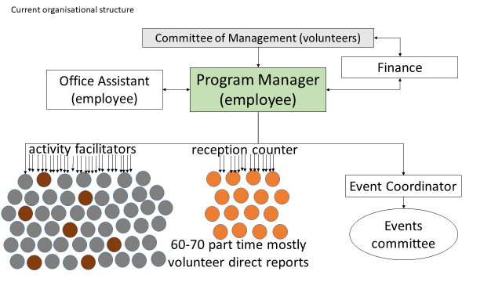
This model hinders the development of PNH.

Diagram 2: New Organisation Structure - CONCEPT
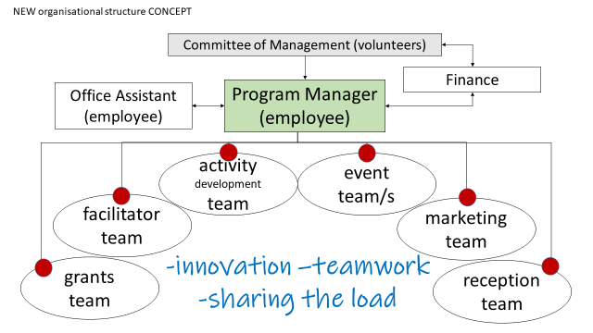
This is a concept designed to allow PNH to evolve. The model requires many members volunteering. The secret is to ensure the roles are small, flexible and have a workable commitment level (no burn-out). The actual roles will be determined by the volunteers and what they can contribute. This won’t be achieved overnight - it is a plan to evolve.

